ABSTRACT

This paper proposes a system for Jarvis AI voice assistant that aims to enhance its capabilities and functionality. The system utilizes various techniques and technologies such as speech recognition, natural language processing, and machine learning algorithms. The proposed system will enable Jarvis to perform a wide range of tasks through voice commands, such as sending emails, scheduling appointments, and making phone calls. The system will also incorporate personalized user profiles to provide a more personalized and efficient experience. Furthermore, the system will include features such as sentiment analysis and emotion recognition to enable Jarvis to better understand the user’s needs and provide appropriate responses. The proposed system will be implemented using Python programming language and various open-source libraries and APIs.
In addition to core functionalities, the system will be designed with modular architecture to facilitate scalability and integration with smart home devices, IoT platforms, and third-party services. Robust data security and privacy protocols will be embedded to ensure safe handling of user information, especially in tasks involving sensitive communication and personal preferences. The overall goal is to create an intuitive, context-aware assistant that evolves with user interactions, delivering seamless and intelligent support across both personal and professional domains.
ACKNOWLEDGEMENT

While presenting this Mini Project on “AI-VOICE ASSISTANT”, We feel that it is our duty to acknowledge the help rendered to me by various persons.

Firstly we thank God for showering his blessings on me. We are grateful to my institution City Engineering College for providing as a congenial atmosphere to carry out the project successfully.

We would like to express our heartfelt gratitude to Dr. S Karunakara, Principal, CEC, Bangalore, for extending his support.

We would also like to express our heartfelt gratitude to Dr. Sowmya, HOD, Computer Science and Engineering whose guidance and support was truly invaluable.

We are very grateful to our guide, Asst.Prof. Ms. Shravya S, and our co guide, Asst.Prof. Mrs. Teja Shree V/ Asst.Prof Mr. Satheesh Kumar G, Department of Computer Science, for their able guidance and valuable advice at every stage of our project which helped us in the successful completion of our project.

We would also have indebted to our Parent and Friends for their continued moral and material support throughout the course of project and helping us in finalize the presentation.

Our hearty thanks to all those who have contributed bits, bytes and words to accomplish this Project.

CHINMAYI P N(1CE23CS036) LEEKHITHA D B(1CE23CS075)
LIKHITHA R K (1CE23CS079)
RAHATH ANJUM M(1CE23CS125)

TABLE OF CONTENTS
- INTRODUCTION 01
  - Background Research 01
  - Objectives and Goals 02
- LITERATURE SURVEY 09
- PROBLEM STATEMENT 11
  - Existing System 11
  - Proposed System 11
- 12
  - 12
  - 13
  - 14
  - 15
- IMPLEMENTATION 16
  - 16
  - 17
  - 18
  - 18
6 SNAPSHOTS 21
APPENDIX 25
CONCLUSION AND FUTURE ENHANCEMENT 39
REFERENCE 40

LIST OF FIGURES

Figure No. | FIGURE NAME | Page No.
Figure 1.1 | Working of Voice Assistants | 4
Figure 1.2 | Detailed Workflow of Model | 12
Figure 4.2 |  | 14
Figure 6.1 |  | 21
Figure 6.2 |  | 21
Figure 6.3 |  | 22
Figure 6.4 |  | 22
Figure 6.5 |  | 23
Figure 6.6 |  | 23
Figure 6.7 |  | 24
Figure 6.8 |  | 24

CHAPTER 01

INTRODUCTION

Artificial Intelligence (AI) voice assistants have rapidly transformed the way humans interact with technology, offering intuitive, hands-free access to digital services. These intelligent systems combine cutting-edge technologies such as speech recognition, natural language processing (NLP), and machine learning to understand and respond to user commands in real time.
Modern AI assistants—like the proposed Jarvis system—are evolving beyond simple task execution. They are becoming context-aware companions, capable of managing complex workflows such as sending emails, scheduling appointments, and even recognizing user emotions. By leveraging personalized user profiles, these assistants tailor their responses and actions to individual preferences, enhancing both efficiency and user satisfaction

BACKGROUND
Background research: AI voice assistants have emerged as transformative tools in human-computer interaction, blending speech recognition, natural language processing (NLP), and machine learning to create intuitive, voice-driven experiences. Early systems were limited to basic command execution, but recent advancements have enabled assistants to understand context, detect sentiment, and personalize responses based on user behavior. Technologies like deep learning and transformer-based models have significantly improved speech-to-text accuracy and semantic understanding, allowing assistants to handle complex queries and multitask across domains. These systems are now widely integrated into smart homes, mobile devices, and enterprise platforms, performing tasks such as sending emails, scheduling appointments, retrieving information, and controlling IoT devices. Modular architectures and open APIs facilitate scalability and interoperability, while robust data privacy frameworks ensure secure handling of sensitive user information. As research progresses, AI assistants are increasingly capable of emotion recognition and adaptive learning, positioning them as empathetic digital companions that evolve with user interactions.

The convergence of technical innovation and user-centric design continues to push the boundaries of what AI voice assistants can achieve, making them indispensable in both personal and professional settings.

Main purpose: The main purpose of an AI voice assistant like JARVIS is to make daily tasks easier and more efficient by allowing users to interact with technology using natural voice commands. It can perform actions such as controlling smart home devices, sending messages, managing reminders and calendars, browsing the internet, playing music, and even running computer programs.
In addition to task automation, JARVIS can learn user preferences over time, personalize responses, and provide real-time information or support. Overall, it serves as an intelligent personal assistant that combines convenience, automation, and personalized interaction to simplify both personal and professional activities.

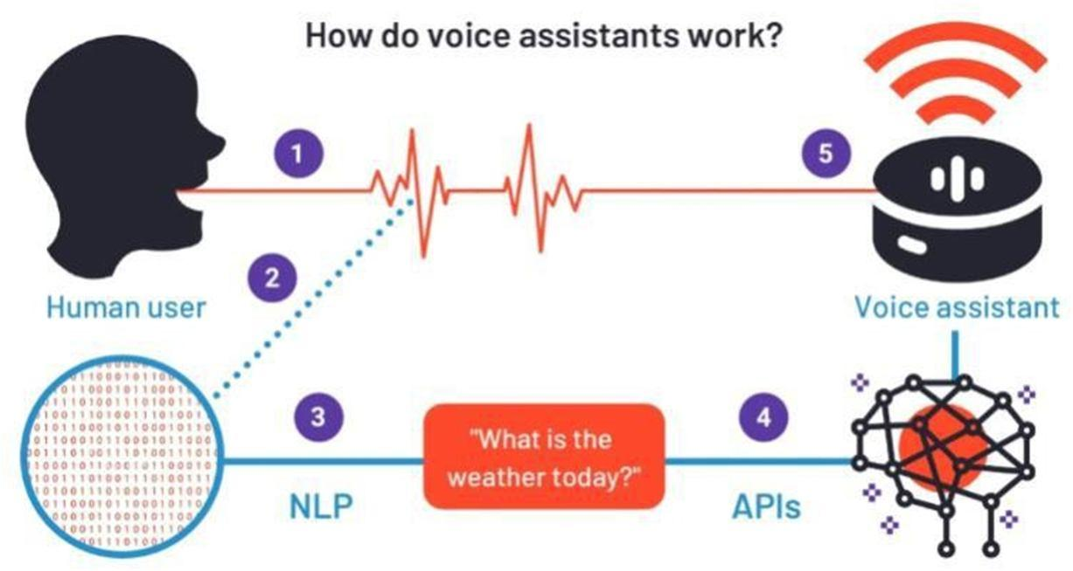

OBJECTIVES AND GOALS
The proposed Jarvis AI voice assistant system is designed to harness the power of speech recognition, natural language processing, and machine learning to deliver a seamless and intelligent user experience. By enabling voice-driven interaction, the system allows users to perform a wide range of tasks such as sending emails, scheduling appointments, and making phone calls with ease. It incorporates personalized user profiles to adapt to individual preferences and usage patterns, while sentiment analysis and emotion recognition enhance its ability to respond empathetically and contextually. The modular architecture ensures scalability and integration with smart home devices, IoT platforms, and third-party services, making Jarvis a versatile assistant across various domains. Additionally, the system emphasizes robust data privacy and security protocols to safeguard sensitive user information.
Aim: The overarching aim of the Jarvis AI system is to create a context-aware, adaptive, and secure digital assistant that evolves through continuous interaction with users. It seeks to go beyond basic automation by delivering personalized support that aligns with both personal and professional needs. Through intelligent learning and emotional sensitivity, Jarvis aspires to become a proactive companion—anticipating user requirements, streamlining daily routines, and enhancing productivity. Ultimately, the goal is to build an assistant that not only understands commands but also understands the user.

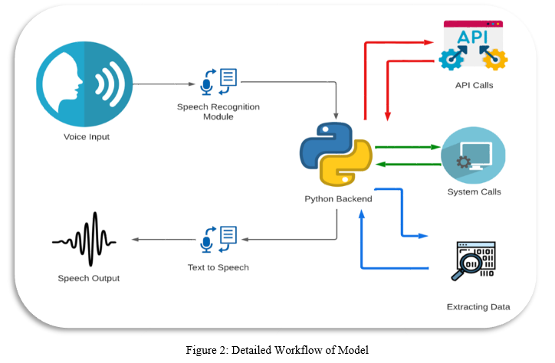

CHAPTER 02

LITERATURE SURVEY

- "AI-Based Voice Assistant Using Python" – IRJET (2023)
This study presents the design and implementation of a desktop-based AI voice assistant using Python and open-source libraries such as Speech Recognition, pyttsx3, and Wolfram Alpha API. The assistant is capable of performing a variety of tasks including sending emails, setting alarms, retrieving factual information, and launching applications. The authors emphasize the importance of modular architecture, which allows for easy integration of additional functionalities and third-party APIs. The system is designed with a focus on user accessibility and simplicity, making it suitable for non-technical users. The paper also discusses the limitations of offline processing and proposes cloud-based extensions for scalability and real-time responsiveness.
- "Voice Assistant for Smart Home Automation" – IJRASET (2022)
This paper explores the integration of voice assistants with smart home environments, leveraging MQTT protocols and IoT frameworks to control devices such as lights, fans, and thermostats through voice commands. The assistant uses speech-to-text conversion and command parsing to interpret user intent and execute corresponding actions. The study highlights the benefits of voice interfaces in enhancing accessibility for elderly and differently-abled users, reducing reliance on physical interfaces. It also addresses challenges related to latency, device compatibility, and network reliability, proposing a hybrid architecture that combines local processing with cloud-based services for optimal performance.
- "Emotion-Aware Voice Assistant Using Sentiment Analysis" – IJSER (2021)
This research introduces an emotion-aware voice assistant that incorporates sentiment analysis to detect and respond to user emotions. Using NLP techniques and machine learning classifiers such as Naive Bayes and SVM, the system analyzes vocal tone, word choice, and sentence structure to infer emotional states like happiness, frustration, or sadness. The assistant then adapts its responses to match the user's mood, aiming to create a more empathetic and engaging interaction. The paper discusses the ethical implications of emotion recognition, including privacy concerns and the potential for manipulation, and suggests safeguards such as user consent and transparency in data handling.
- "Voice Assistant for Visually Impaired Users" – IEEE Xplore (2019)
This paper focuses on designing a voice assistant tailored for visually impaired users, emphasizing simplicity, reliability, and offline functionality. The system uses a minimalistic command set and provides audio feedback for confirmation and error handling. It is capable of reading out messages, navigating menus, and performing basic tasks without requiring visual input. The authors highlight the importance of accessibility in AI design and propose enhancements such as gesture-based input and Braille-compatible output. The study also discusses the challenges of speech recognition in noisy environments and suggests noise-cancellation techniques and adaptive microphone arrays as potential solutions.
- "Comparative Study of AI Voice Assistants: Siri, Alexa, Google Assistant" – IJCRT (2020)
This comparative analysis evaluates the performance, contextual understanding, and ecosystem integration of leading commercial voice assistants—Siri, Alexa, and Google Assistant. The study uses standardized queries to assess response accuracy, latency, and naturalness of interaction across different platforms. It also examines language support, device compatibility, and third-party integration capabilities. The authors conclude that while all three assistants perform well in basic tasks, Google Assistant excels in contextual follow-up queries, Alexa leads in smart home integration, and Siri offers deeper integration with Apple’s ecosystem. The paper provides valuable insights into design trade-offs and user experience optimization.

CHAPTER 03

PROBLEM STATEMENT

Most existing AI voice assistants struggle to deliver truly personalized and context-aware interactions. They rely heavily on predefined commands, lack emotional intelligence, and offer limited adaptability to user preferences or evolving needs. Integration with smart devices and third-party services is often fragmented, reducing their overall utility.
The proposed Jarvis AI system aims to overcome these limitations by combining speech recognition, NLP, and machine learning to create a modular, scalable, and emotionally responsive assistant. It will support personalized profiles, sentiment analysis, and secure data handling—enabling intelligent, voice-driven support across both personal and professional domains.

EXISTING SYSTEM

- Siri (Apple)
  - Limited contextual memory across sessions
  - Restricted to Apple ecosystem for full functionality
  - Minimal emotional awareness or sentiment adaptation
- Alexa (Amazon)
  - Strong smart home integration but weak conversational depth
  - Privacy concerns due to continuous listening features
  - Limited personalization beyond basic preferences
- Google Assistant
  - Integration with third-party apps can be inconsistent
  - Responses can feel generic or impersonal
  - Excellent Search and contextual flow-up but lacks emotional intelligence.

- Cortana (Microsoft, now deprecated)
  - Poor adoption and limited cross-platform support

  - Lacked advanced NLP and emotional recognition
  - Discontinued due to lack of user engagement
- Bixby (Samsung)
  - Strong device control but weak third-party ecosystem
  - Limited natural language understanding
  - Struggles with complex or multi-step commands

PROPOSED SYSTEM

The proposed Jarvis AI voice assistant system is designed to deliver intelligent, voice-driven support by integrating speech recognition, natural language processing (NLP), and machine learning algorithms. It will allow users to perform a wide range of tasks—such as sending emails, scheduling appointments, and making phone calls—through natural voice commands. The system will incorporate personalized user profiles to adapt to individual preferences and usage patterns, enabling more relevant and efficient interactions. Sentiment analysis and emotion recognition will be embedded to help Jarvis understand the user's mood and respond empathetically.

Built using Python and open-source libraries, the system will follow a modular architecture to ensure scalability and easy integration with smart home devices, IoT platforms, and third-party services. Security and privacy protocols will be prioritized to protect sensitive user data, especially in tasks involving personal communication and preferences. Jarvis will continuously learn from user interactions, evolving into a context-aware assistant that delivers seamless support across
both personal and professional domains

Advantages of Proposed System
- Personalized Interaction: Jarvis leverages user profiles to tailor responses and actions based on individual preferences, routines, and historical behaviour. This personalization ensures that the assistant becomes more intuitive over time, offering suggestions and executing tasks in ways that align with the user's habits and expectations.
- Emotion and Sentiment Recognition: By integrating sentiment analysis and emotion detection, Jarvis can interpret the user's mood and tone during interactions. This allows the assistant to respond empathetically—offering encouragement, adjusting its tone, or even deferring tasks when the user appears stressed or frustrated—enhancing emotional engagement and trust.
- Voice-Driven Task Automation: Users can perform a wide range of tasks—such as sending emails, making phone calls, setting reminders, and controlling smart devices—using natural voice commands. This hands-free functionality boosts productivity and accessibility, especially for users with physical limitations or multitasking needs.
- Modular and Scalable Architecture: The system is built with a modular design, allowing developers to add or modify components without disrupting the core functionality. This makes Jarvis highly scalable and adaptable to future technologies, including new APIs, smart devices, and evolving user requirements.
- Integration with Smart Devices and IoT Platforms: Jarvis is designed to seamlessly connect with smart home systems, IoT platforms, and third-party services. This enables users to control lighting, appliances, security systems, and more through voice commands, creating a unified and intelligent living or working environment.
- Robust Data Security and Privacy: Given the sensitivity of tasks like communication and scheduling, Jarvis incorporates strong encryption, access control, and anonymization protocols. These measures ensure that user data is handled securely, maintaining confidentiality and compliance with data protection standards.
- Continuous Learning and Adaptability: Through machine learning, Jarvis evolves with each interaction—refining its understanding of user preferences, improving task execution, and expanding its knowledge base. This dynamic learning capability ensures that the assistant remains relevant and increasingly effective over time.
- Cross-Domain Utility: Jarvis is designed to support both personal and professional domains. Whether managing daily routines, coordinating meetings, or retrieving technical information, the assistant adapts to diverse contexts, making it a versatile tool for students, professionals, and home users alike.
- Open-Source Flexibility: Built using Python and open-source libraries, Jarvis offers flexibility for customization and community-driven enhancements. Developers can modify modules, integrate new features, or deploy the system across various platforms without licensing constraints.

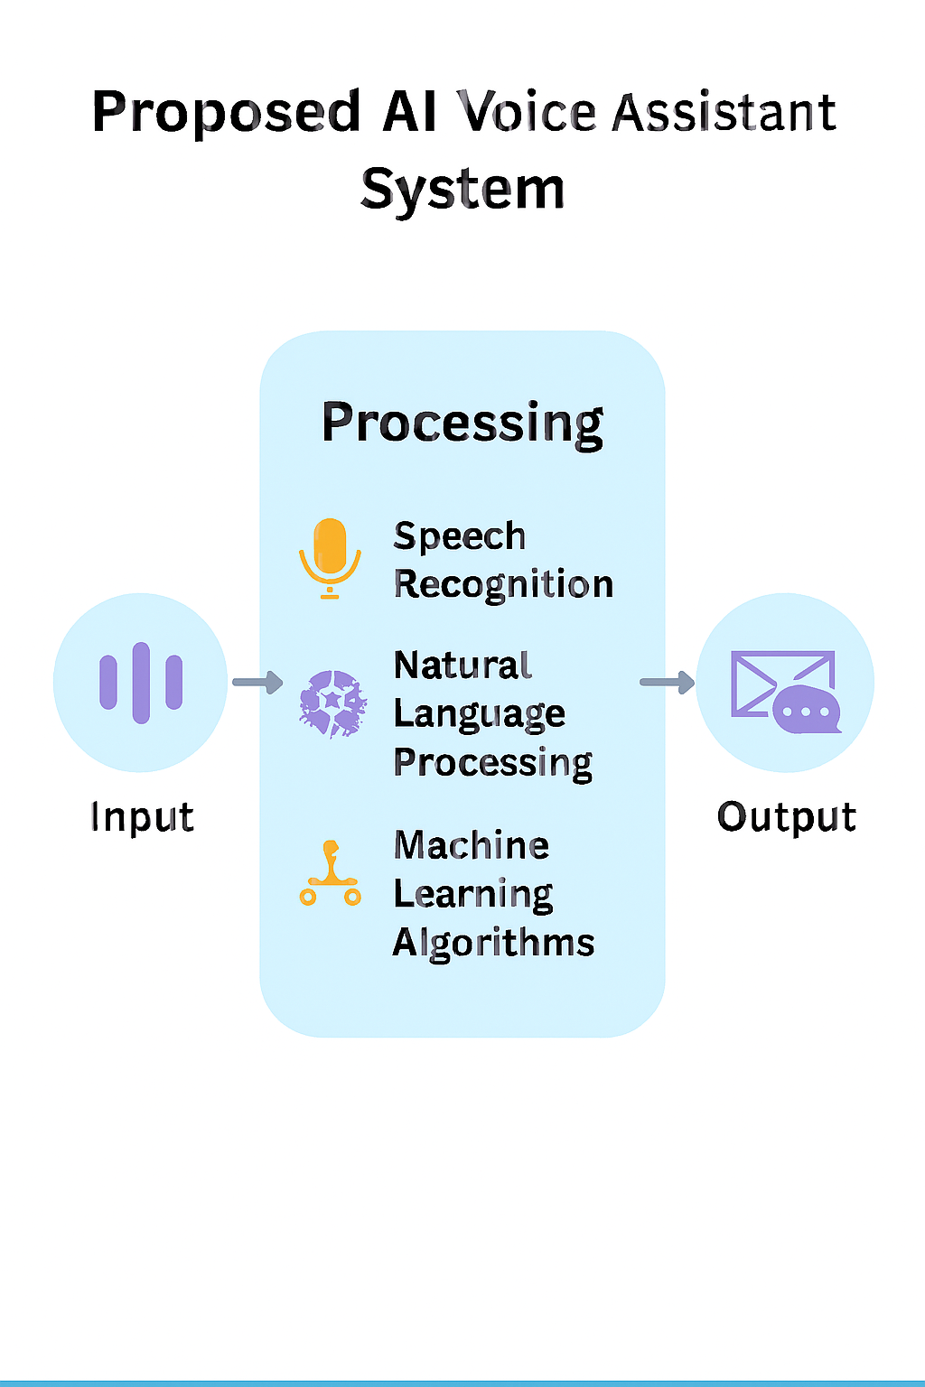
.

CHAPTER 04

SYSTEM REQUIREMENTS SPECIFICATION
A System Requirements Specification (SRS) for an AI voice assistant outlines the functional and
non-functional requirements, external interfaces, and system constraints to guide the development
process

FUNCTIONAL REQUIREMENTS

The functional requirements for an AI voice assistant fundamentally involve its ability to understand spoken language, process the meaning in context, execute tasks or retrieve information, and respond in a natural-sounding voice.

Streamlit Integration -------------------------

The integration with Streamlit, an open-source platform for creating web applications, will be a key aspect of our system. Streamlit simplifies the development of interactive and user-friendly interfaces for machine learning models. It allows for seamless integration of algorithms and data visualization, making it accessible to both technical and non-technical users. Streamlit is a small and easy web framework which helps us to build beautiful websites. The main reason for using stream lit is that it offers very user-friendly experience, and we don’t need to have a prior knowledge of HTML, CSS and JAVASCRIPT. Streamlit is mostly used for deploying machine learning models without using any external cloud integrations. Some of the applications of Streamlit are it helps to deploy Machine learning and deep learning models; it can also help us to build a front end for a normal code. The output can be viewed as local server in your web browser.

System Workflow

For a general-purpose or personal AI assistant that uses the "Jarvis" name (often inspired by the Iron Man character), the workflow typically involves:

User Input: The system receives a command from a user, usually via voice (speech) or text.

Speech Recognition (if voice input): The spoken words are converted into digital signals and then transcribed into text format using a speech recognition module.

Natural Language Processing (NLP) / Intent Identification: The transcribed text is processed by an NLP engine to understand the user's intent, context, and extract relevant entities.

Task Delegation/Execution: Based on the identified intent, the central AI (Jarvis) delegates the task to a specialized agent or specific function/module (e.g., a "Communication Supervisor" for email tasks, a "Travel Agent" for travel plans, an API call for real-time data).

Information Retrieval/Action: The relevant agent or module performs the requested task, which may involve:

Accessing internal knowledge bases using Retrieval-Augmented Generation (RAG).

Running a specific software application or script.

Interacting with external APIs or IoT devices (smart home control).

Performing data analysis or calculations.

Response Generation: The result of the action or the retrieved information is used to generate an appropriate response.

Speech Synthesis (if voice output): The text response is converted into audible speech using text-to-speech technology.

User Output: The response is delivered to the user, either as spoken dialogue, a visual display on screen, or by completing the requested action.

This type of JARVIS system also uses machine learning to continuously learn from interactions, adapt to user preferences, and improve its performance over time.

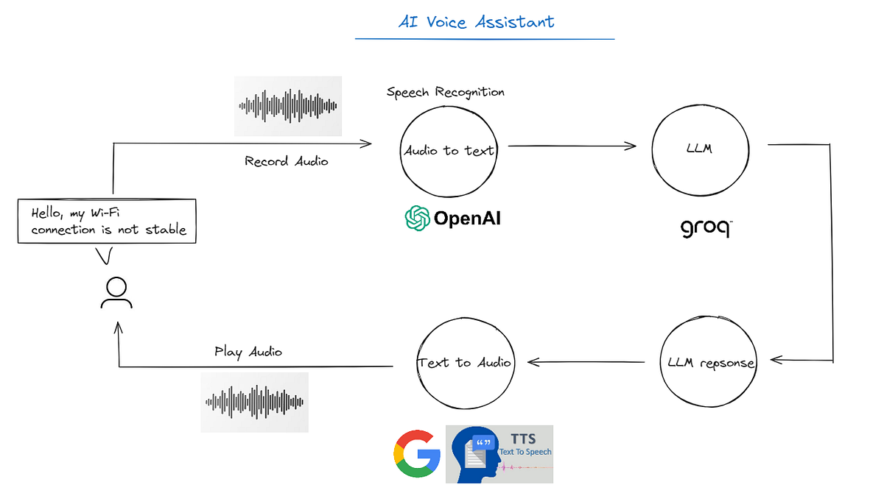
Figure 4.1: System Workflow

SOFTWARE REQUIREMENTS
This project is implemented in Python and requires specific libraries for NLU, ASR, TTS, and system integration.

Category | Primary Libraries/Components | Description
Deep Learning | TensorFlow/Keras | Neural Network for Intent Classification.
Data Processing | Tokenizer(Keras), LabelEncoder (Sklearn) | Used for converting text to numerical data and encoding/decoding intent tags.
Speech I/O | speech_recognition, pyttsx3 | Handles Voice-to-Text (ASR) and Text-to-Speech (TTS).
System Automation | pyautogui, psutil, subprocess | Controls volume, opens/closes applications, and checks system status.
Data Storage | intents.json, .pkl, .h5 files | Stores conversational data, pre-processing objects, and the trained model weights.

Objectives for Input Design
The software input design objectives focus heavily on effective human-computer interaction, performance, and robustness:
- Accuracy of Interpretation: The primary objective is to achieve a high degree of accuracy in converting diverse inputs (primarily speech, but also text) into actionable commands or queries. This involves robust speech recognition (ASR) and natural language processing (NLP) to handle various accents, grammatical phrasings, and contexts.
- Low Response Latency: The software must process input and initiate a response quickly to ensure real-time, fluid interaction. The target response time is often less than two seconds to provide a seamless user experience.

- Intuitive User Experience (UX): The input interface, whether voice-based or graphical (GUI), must be user-centric and easy to use. The system should gracefully handle ambiguous queries or errors by asking for clarification rather than assuming incorrectly.
- Robust Error Handling: The software should be designed to handle invalid inputs, network errors (for online tasks), or unknown commands gracefully, providing meaningful error messages or prompts for rephrasing.
- Modularity and Scalability: The input software components (e.g., speech-to-text module, NLP engine, API connectors) should be modular, allowing for easy updates, integration of new APIs or functionalities, and future enhancements without significant restructuring.
- Security and Privacy: Input data must be handled securely. This involves implementing robust authentication mechanisms (like passwords or potentially voice biometrics) and ensuring data privacy, especially for sensitive information.
- Context Management: The software should maintain context across multi-turn conversations to provide relevant and personalized responses, remembering information from previous interactions within a session.

HARDWARE REQUIREMENTS
- Input: Functional Microphone for voice commands.
- Output: Speakers or Headphones for audible responses.
- Processing: A standard desktop or laptop capable of running Python 3 and the listed libraries.
Objectives for Output Design
The primary objectives for the hardware output are focused on delivering a clear, fast, and reliable user experience, primarily via audio and visual means:
- Audible, Human-Like Responses: The system must be capable of generating clear, high-quality audio responses that sound natural and are easily understood. This requires quality speakers or audio output jacks to ensure the user receives the verbal feedback clearly.
- Low Latency (Real-time Interaction): A critical objective is for the output to be generated and delivered with minimal delay (ideally under 300ms for conversational AI), ensuring fluid, real-time interaction that prevents user frustration. The hardware (CPU, GPU, RAM) must support fast text-to-speech (TTS) processing.

- Intuitive Visual Feedback (GUI): The hardware must support a clear display for a graphical user interface (GUI) to provide visual confirmation of actions, display search results, weather updates, or other information. This is particularly relevant for desktop or smart-display variants of JARVIS.
- Hands-Free Functionality Support: The entire output system (audio and visual) must be designed to enable users to receive information and control their environment without needing manual interaction with the hardware itself.
- Integration with IoT Devices: The hardware should facilitate output as control signals to other smart devices (e.g., smart home lighting, security systems), requiring appropriate communication ports and wireless connectivity modules (Wi-Fi, Bluetooth)
- Accessibility: Output hardware should consider users with disabilities, perhaps including screen reader compatibility for the GUI or supporting alternative output methods like haptic feedback where applicable.
- Scalability: The output hardware framework should be flexible to accommodate future growth, such as adding support for multi-screen displays or additional smart home device integration.

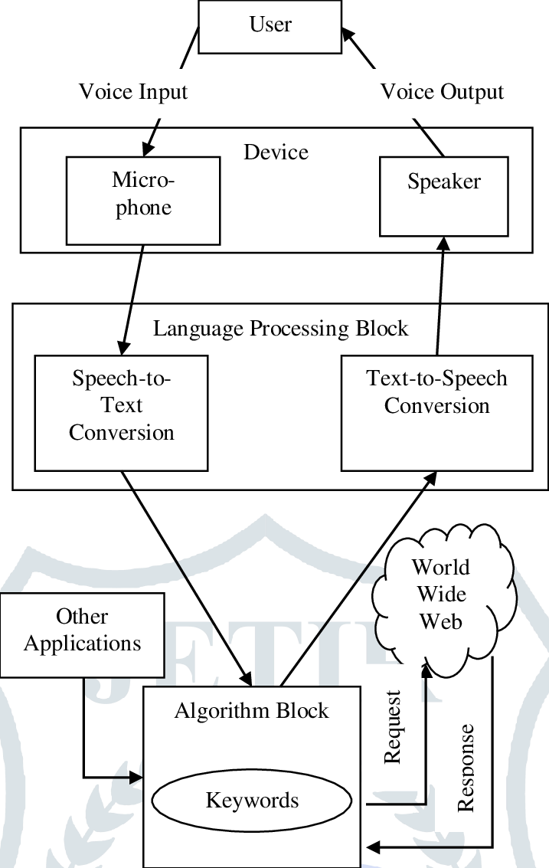
Figure 4.2: Proposed System Software and Hardware Requirements

CHAPTER 05

SYSTEM ANALYSIS AND DESIGN
System analysis and design (SAD) for an AI voice assistant involves a structured methodology to build a system that can effectively understand and respond to human speech. The process focuses on defining the system's purpose, designing the interaction flow, integrating core AI technologies, and ensuring continuous improvement.

SYSTEM ARCHITECTURE

The system is designed as a hybrid conversational assistant, combining a Deep Learning Intent Classifier with a Rule-Based Action Executor.

1. Input Processing Layer

Voice Input: User speech is captured via a microphone.

Automatic Speech Recognition (ASR): Converts voice to text query using the speech_recognition library.

Text Input: Direct command line or GUI text input (as seen in model_test.py).

2. Natural Language Understanding (NLU) - The Core Model

Pre-processing: Tokenization and padding of the input sentence (using tokenizer.pkl).

Intent Classification: A trained Deep Neural Network (chat_model.h5) predicts the user's intent tag (e.g., 'greeting', 'joke', 'volumeup') from the features defined in intents.json.

Action Mapping: The predicted intent tag is mapped to a specific action type.

3. Action Execution and Response Layer

Conversational Response: For intents like 'greeting' or 'jokes', a random, context-appropriate response is fetched from intents.json.

System/App Control: For intents like 'volumeup' or 'open calculator', system libraries (pyautogui, subprocess) execute the command.

Text-to-Speech (TTS): All responses (text or action confirmation) are converted back into speech using pyttsx3.
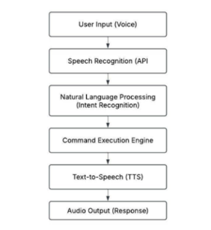

Figure 5.1: System Architecture

FLOW DIAGRAMS
    - UML DIAGRAMS
In the context of our healthcare diagnostic project, Unified Modelling Language (UML) diagrams serve as visual representations to illustrate the system's architecture, components, and interactions. These diagrams include various types, such as Use Case Diagrams depicting system functionalities and user interactions, Class Diagrams outlining the structure of classes and their relationships, and Sequence Diagrams illustrating the sequence of actions during disease prediction. UML diagrams are valuable tools for our project, aiding in communication among team members and stakeholders, ensuring a shared understanding of the system's design and functionality. They provide a comprehensive overview of the project's structure and behaviour, facilitating effective collaboration and implementation of machine learning algorithms within the healthcare diagnostic framework.

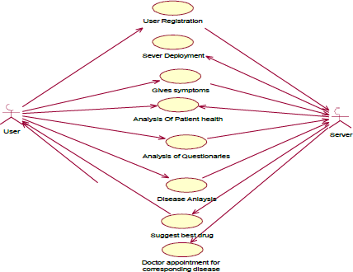

Figure 5.3: UML Diagram

DATAFLOW DIAGRAM
The DFD is also called as bubble chart. It is a simple graphical formalism that can be used to represent a system in terms of input data to the system, various processing carried out on this data, and the output data is generated by this system.
The data flow diagram (DFD) is one of the most important modelling tools. It is used to model the system components. These components are the system process, the data used by the process, an external entity that interacts with the system and the information flows in the system.
DFD shows how the information moves through the system and how it is modified by a series of transformations. It is a graphical technique that depicts information flow and the transformations that are applied as data moves from input to output. DFD is also known as bubble chart.
A DFD may be used to represent a system at any level of abstraction. DFD may be partitioned into levels that represent increasing information flow and functional detail.

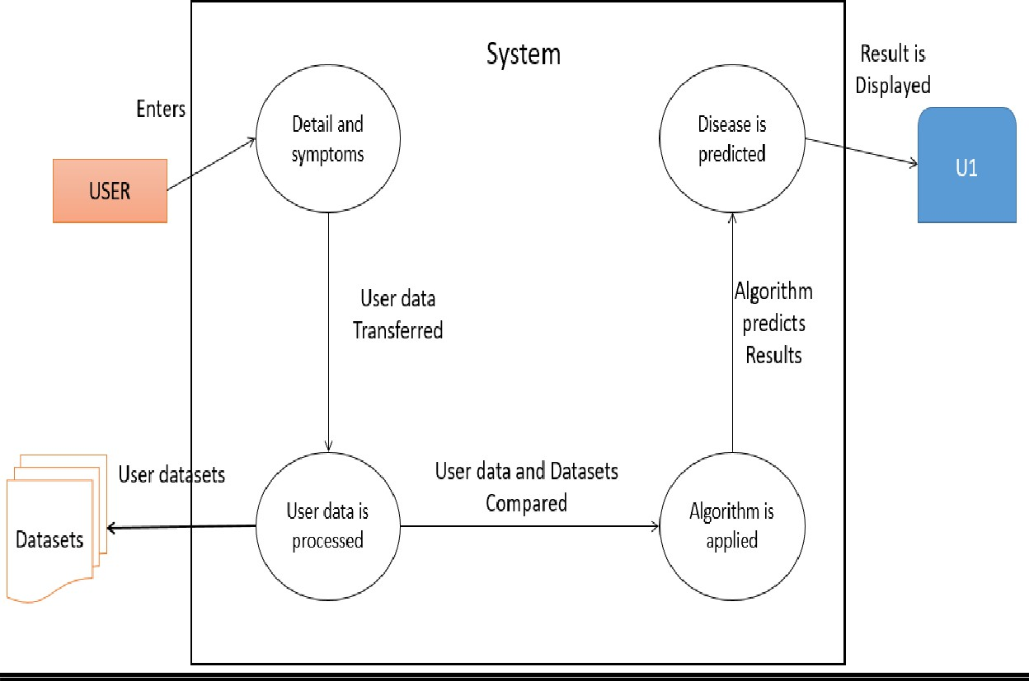
Figure 5.4: Data Flow Diagram

ER DIAGRAM
The Entity-Relationship (ER) Diagram serves as a visual representation of the data model, illustrating the relationships between various entities within the system. Entities in the ER Diagram represent key components such as patients, medical records, and diagnostic results. Relationships between these entities, such as the association between patient data and diagnostic outcomes, are defined and visually depicted.
Attributes of each entity, such as patient ID, symptoms, and disease predictions, are detailed within the ER Diagram, providing a comprehensive overview of the data structure. The ER Diagram aids in understanding the organization of data, ensuring clarity in the relationships between different components of the healthcare diagnostic framework.
By utilizing the ER Diagram, our project aims to design a robust and well-structured data model that facilitates efficient data management, retrieval, and relationships essential for accurate disease predictions and comprehensive healthcare insights.

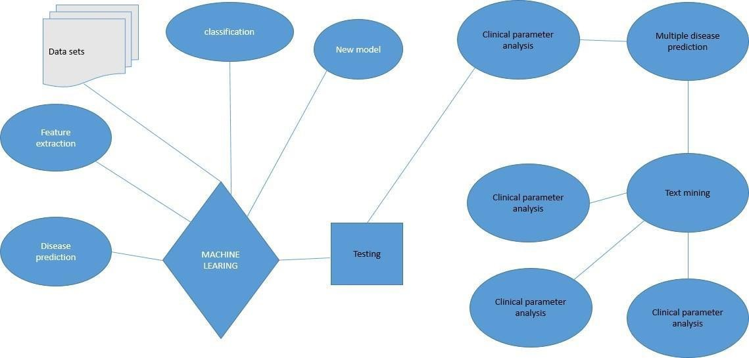
Figure 5.5: ER Diagram

CLASS DIAGRAM
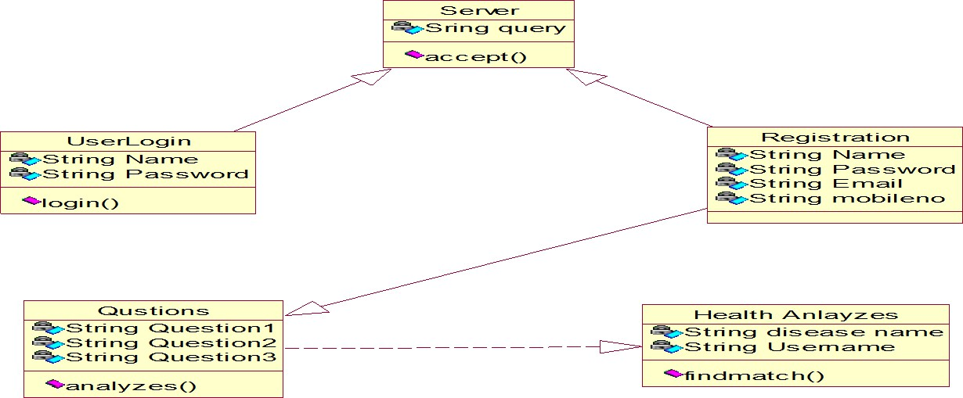

Figure 5.6: Class Diagram

Class diagrams are widely used to describe the types of objects in a system and their relationships. Class diagrams model class structure and contents using design elements such as classes, packages and objects. Class diagrams describe three different perspectives when designing a system, conceptual, specification, and implementation. These perspectives become evident as the diagram is created and help solidify the design. Class diagrams are arguably the most used UML diagram type. It is the main building block of any object-oriented solution. It shows the classes in a system, attributes and operations of each class and the relationship between each class. In most modelling tools a class has three parts, name at the top, attributes in the middle and operations or methods at the bottom. In large systems with many classes related classes are grouped together to create class diagrams. Different relationships between diagrams are show by different types of Arrows.

ACTIVITY DIAGRAM
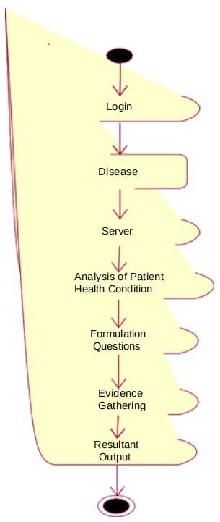
Activity Diagram serves as a visual representation of the dynamic aspects of the system, illustrating the flow of activities or processes involved in disease prediction. It focuses on the sequence of actions, decisions, and control flows within the system. Activities in the diagram represent tasks or processes, such as data input, algorithm execution, and result presentation. Control flows depict the order in which these activities occur, showcasing decision points and branching based on conditions. Swim lanes may be used to represent different entities or system components involved in the activities, providing clarity on responsibilities. The Activity Diagram is particularly beneficial in understanding the workflow of disease prediction, from the initial input of patient data to the final presentation of diagnostic results. It aids in identifying potential bottlenecks, parallel processes, and decision points within the system, contributing to a comprehensive understanding of the dynamic aspects of the healthcare diagnostic framework. This diagram is particularly useful in showcasing the entire disease prediction process, from the initial input of patient data to the final presentation of diagnostic results. It aids in identifying potential bottlenecks, parallel processes, and decision points within the system. The clarity provided by the Activity Diagram contributes to effective communication among team members and stakeholders, ensuring a shared understanding of the dynamic aspects of our healthcare diagnostic solution.

Fig 5.7 Activity Diagram

SEQUENCE AND COLLABORATION DIAGRAMS
The Collaboration Diagram is valuable for highlighting the dynamic interactions between objects, emphasizing the flow of information and the dependencies that exist during the disease prediction sequence. It aids in visualizing the real-time collaboration between various system components, contributing to a comprehensive understanding of the communication patterns within the healthcare diagnostic system.
Sequence diagrams in UML shows how object interact with each other and the order those interactions occur. It’s important to note that they show the interactions for a particular scenario. The processes are represented vertically, and interactions are show as arrows.

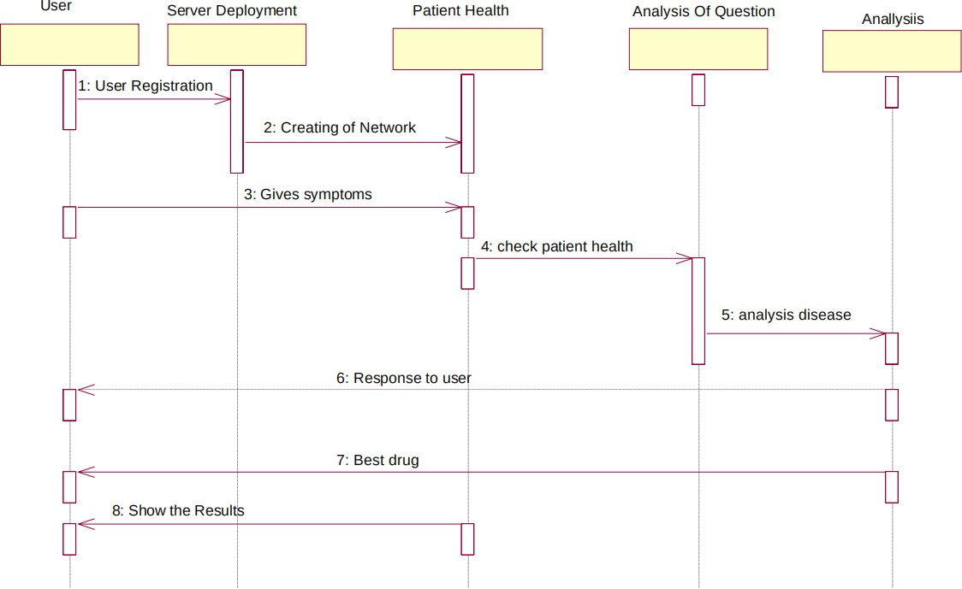

Figure 5.8: Sequence Diagram

Typically includes lifelines representing entities such as the user, the system, and external services. Messages exchanged between these lifelines depict the sequence of interactions, indicating the flow of information during the disease prediction process. Activation bars show the duration of each interaction.

The Sequence Diagram provides valuable insights into the dynamic behaviour of the system, illustrating the step-by-step execution of activities. It is particularly useful in showcasing how different components, such as user input, machine learning algorithms, and result presentation, work in tandem to predict diseases accurately. By utilizing the Sequence Diagram, our project aims to ensure a clear understanding of the temporal aspects of the healthcare diagnostic framework, guiding the implementation of these interactions effectively.
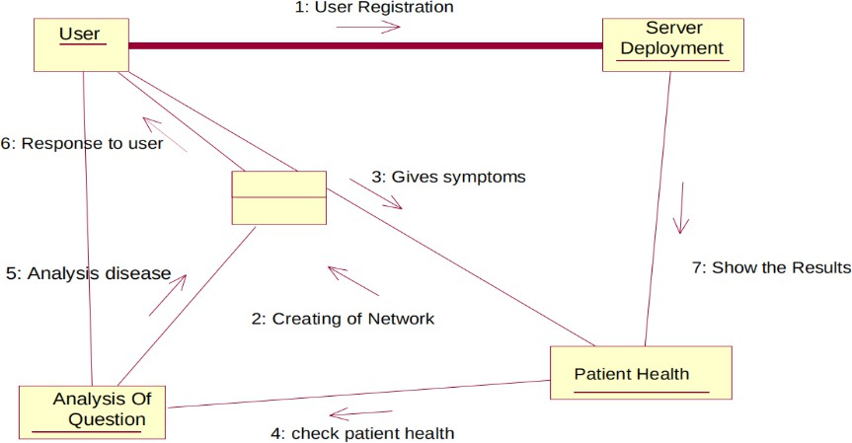

Figure 5.9: Collaboration Diagram

Typically includes objects representing entities like users, the system, and external services. Connecting lines and arrows indicate the communication pathways, depicting the messages exchanged between objects. This visual representation helps in understanding the relationships and dependencies between different components in the healthcare diagnostic framework.

CHAPTER 06

IMPLEMENTATION
The implementation of an AI voice assistant fundamentally relies on four core technological components that work in sequence: Automatic Speech Recognition (ASR), Natural Language Processing (NLP), Dialogue Management, and Text-to-Speech (TTS).

Implementation Steps
Two-Phase Implementation: Training and Live Execution
The project follows a standard Machine Learning workflow, separated into training the model and deploying the live assistant.
Phase 1: Training (model_train.py)
- Data Ingestion: Load training patterns and response tags from intents.json.
- Feature Engineering:
  - Label Encoding: Map intent tags (e.g., 'greeting') to numerical classes (using label_encoder.pkl).
  - Tokenization: Convert text patterns into sequences of numbers (using tokenizer.pkl).
  - Padding: Standardize sequence length for model input.
- Model Build & Training: Create a simple DNN model (Embedding \rightarrow GlobalAveragePooling1D \rightarrow Dense layers) and train it on the padded sequences to classify intent.
- Artifact Saving: Save the trained model (chat_model.h5), tokenizer.pkl, and label_encoder.pkl.
Phase 2: Live Execution (main.py / model_test.py)
- Initialization: Load all saved artifacts (model, tokenizer, encoder) into memory.
- Listening Loop: Continuously wait for a voice command.
- Command Handling:
  - If the command is a direct system action (e.g., "open calculator"), execute the rule-based function.
  - If the command is a conversational query (e.g., "how are you"), classify intent using the NLU model and provide the corresponding response via TTS.
Data Collection and Preprocessing----------------------------

    - Data Sources: Public datasets from sources like Kaggle, UCI Machine Learning Repository, and medical journals (e.g., datasets for diabetes, heart disease, liver disease, etc.). Real-world anonymized data from hospitals or health organizations.
    - Data Types: Numeric (e.g., glucose levels, blood pressure), Categorical (e.g., gender, symptoms like "chest pain") and Text data (e.g., patient descriptions).
    - Preprocessing Steps: Handling Missing Data, Outlier Detection, Feature Scaling, Encoding Categorical Features and Feature Selection.

Model Selection and Training ---------------------------

    - Approach 1: Disease-Specific Models

- Train separate models for each disease (e.g., diabetes prediction, heart disease classification).

    - Approach 2: Unified Multi-Disease Model

- Use multi-label classification to predict multiple diseases simultaneously.

Algorithms:

- Logistic Regression, Random Forest, XGBoost (for simpler models).

- Neural Networks or Deep Learning for complex relationships.

    - Steps: 1. Split data into training, validation, and testing sets. 2. Train models on labelled data with appropriate algorithms. 3. Perform hyperparameter tuning using GridSearchCV or RandomizedSearchCV. 4. Evaluate with metrics like accuracy, F1 score, ROC-AUC, and precision-recall curves. 5. Save models using libraries like joblib or pickle for deployment.

Backend Development

    - Frameworks: Flask or Django.

Implementation:

- Develop RESTful APIs to handle requests (e.g., receive patient data, process predictions, and return results).
- Use model inference pipelines: Load pre-trained models and pass user inputs to generate predictions.
- Ensure data validation (e.g., checking input types, ranges).

Frontend Development

  - Tools: HTML, CSS, JavaScript (or frameworks like React or Vue.js).

Features:

- Input Forms:

  - Collect user health data (e.g., age, BMI, symptoms, medical history).

- Dynamic Validation:

  - Ensure proper input (e.g., restrict invalid values for glucose levels or age).

- Output Visualization:

  - Display prediction results as probabilities, heatmaps, or graphs.

Deployment

- Platforms: AWS, Azure, Google Cloud, Streamlit Cloud or Heroku.

Steps:

- Containerize the application using Docker for portability.

- Deploy backend and frontend as microservices.

- Use a database (e.g., PostgreSQL, MongoDB) for storing patient records and model logs.

- Set up CI/CD pipelines to ensure smooth updates.

- Secure the application with HTTPS, authentication, and data encryption.

Advanced Features

Multi-Disease Prediction

    - Enable simultaneous risk assessment for multiple diseases (e.g., diabetes, liver disease, and heart disease).
    - Use ensemble models or neural networks to handle dependencies between diseases.

Data Visualization

    - Graphs showing trends in risk levels over time.

    - Compare user data with population averages (e.g., BMI vs. normal BMI ranges).

Explainable AI (XAI)

    - Use techniques like SHAP or LIME to explain model predictions.

    - Example: Show how specific features (e.g., glucose level, age) contributed to disease risk.

Feedback Mechanism

    - Allow users to input feedback on predictions to improve model accuracy over time.

Tools & Technologies
    - Programming Languages: Python for ML models, JavaScript for frontend.

Libraries:

- Machine Learning: Scikit-learn, TensorFlow, Keras, XGBoost.

- Data Processing: Pandas, NumPy.

- Visualization: Matplotlib, Seaborn, Plotly.

    - Databases: MySQL, MongoDB, or SQLite.

    - Version Control: GitHub/GitLab for collaborative development.

    - Deployment: Docker, Kubernetes, Nginx, or cloud services.

Challenges and Mitigation

Data Imbalance:

  - Use SMOTE (Synthetic Minority Oversampling Technique) to balance datasets.

Interpretability:

  - Incorporate XAI to build trust in predictions.

Scalability:

  - Use scalable architectures like microservices and load balancers.

Data Privacy:

  - Ensure compliance with GDPR, HIPAA, or other regulations.

CHAPTER 07

RESULTS AND DISCUSSIONS

The Multiple Disease Prediction System effectively forecasts Diabetes, Heart Disease, and Parkinson's, marking a substantial achievement. This section provides a detailed analysis of the performance of each algorithm, user interactions with the Streamlit interface, and the broader implications for healthcare.

Visualizing the Project Journey:
Each snapshot presented below details many steps, how the system/application workflows, emphasizing the simplicity and clarity of the design. It includes varies steps involved in execution which has a result are as below snapshots,
Step1: Download CSV Files for Diabetes, Heart Disease and Parkinsons Diseases from Kaggle.

Step2: Upload them into a Google Colab Notebooks (instead Jupyter Notebooks). Run every line of code one after the other and download .sav extensioned file from Colab as shown below to drive.
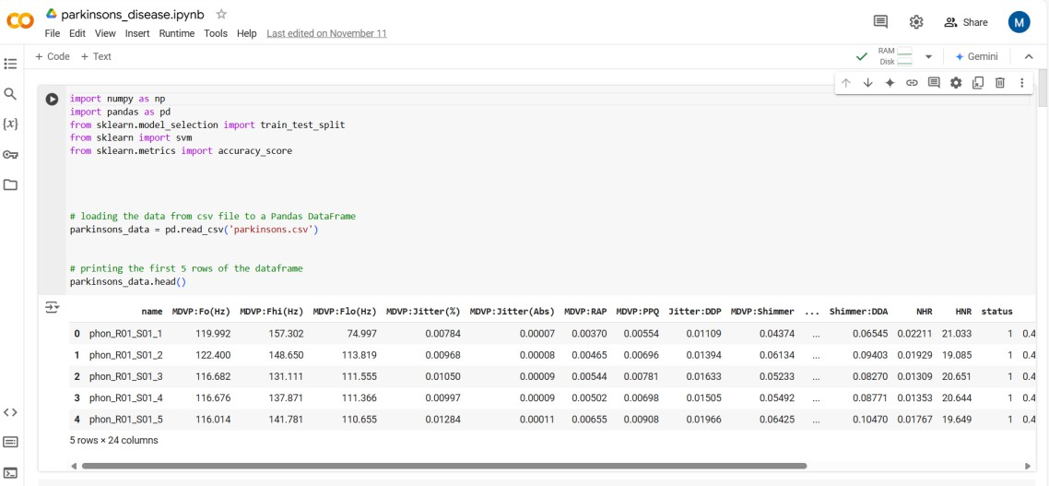
Figure 7.1: Google Colab Example for Parkinsons Disease Prediction File

Step3: Create a empty folder on desktop, move all the CSV Files, Colab notebooks(.ipynb) and
.sav files to it

Step4: install anaconda navigator, create a new environment as “machine learning”. Use it and install spyder and launch it.
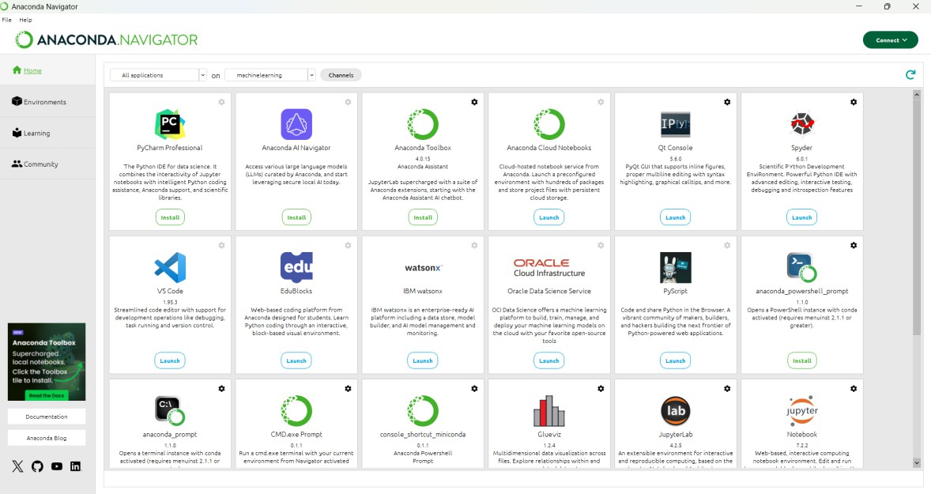
Figure 7.2: Anaconda Navigator with Environment called Machine Learning
Step5: open spyder, code it through using Python programming language. After coding install required libraries in anaconda terminal in created environment.
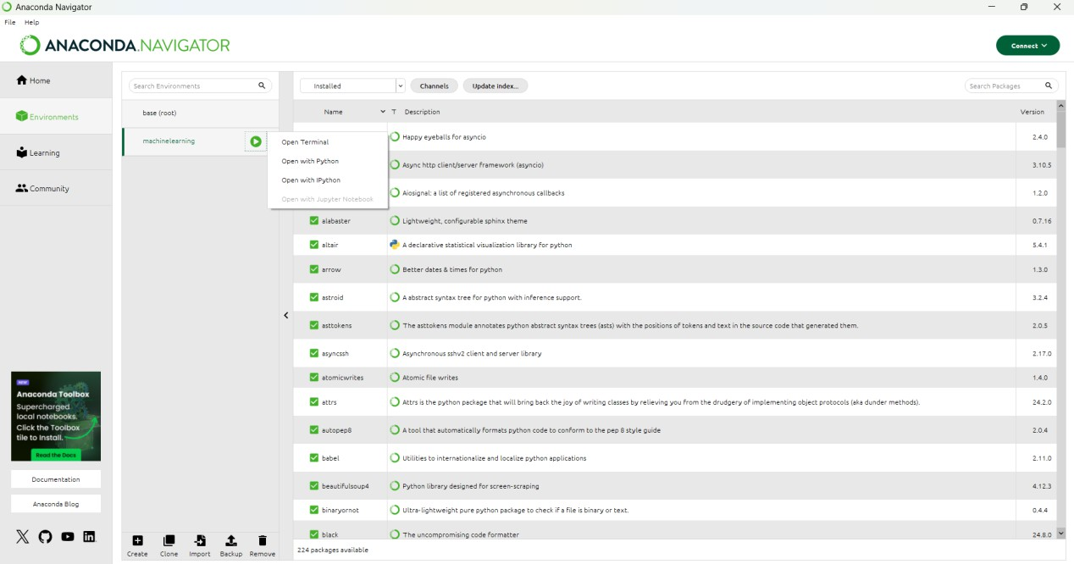

Figure 7.3: New Terminal in Machine learning Environment

Step6: save as app.py and go to anaconda navigator, open new terminal from created environment, run a command given to execute the application (used Streamlit interface)
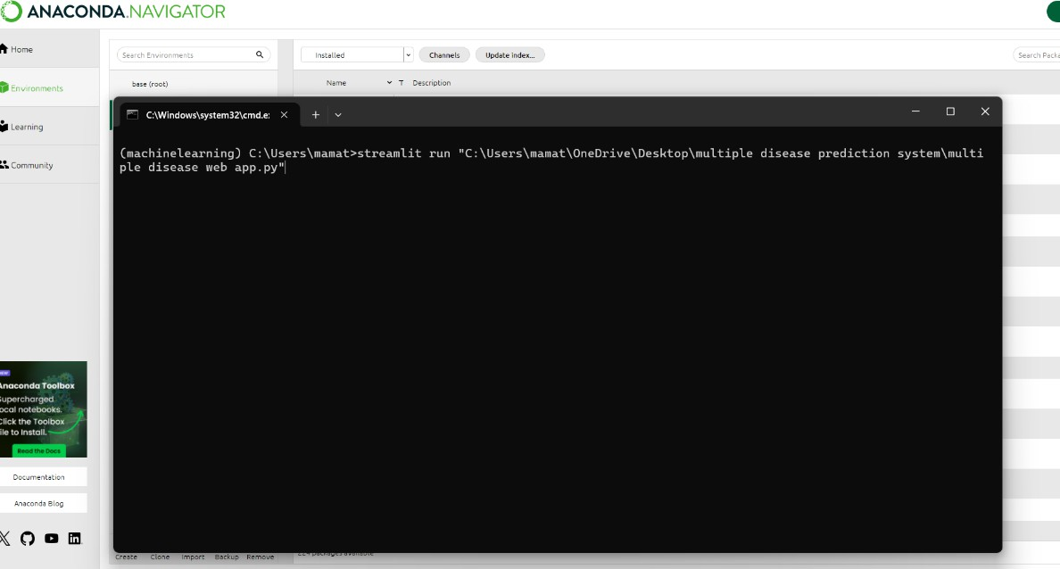
Figure 7.4: Streamlit Command to Run

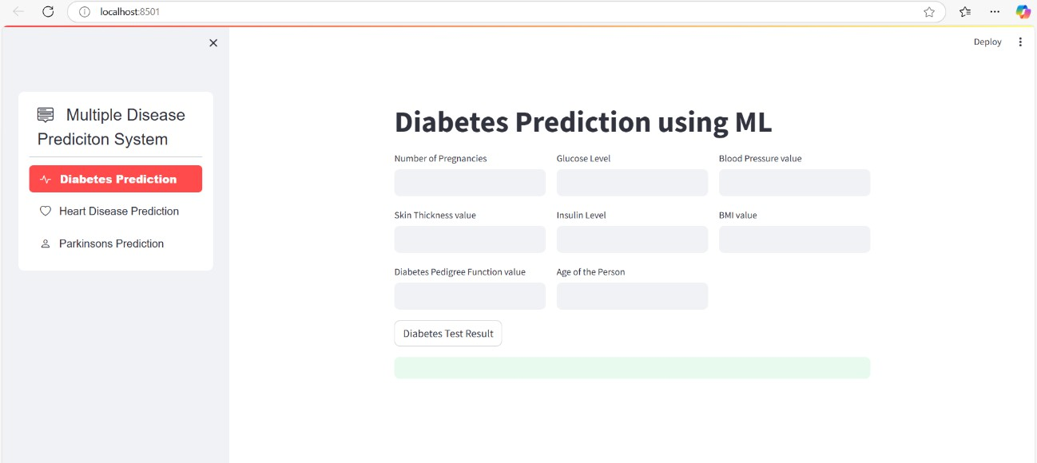
Figure 7.5: Displays the Multiple Disease Prediction Application

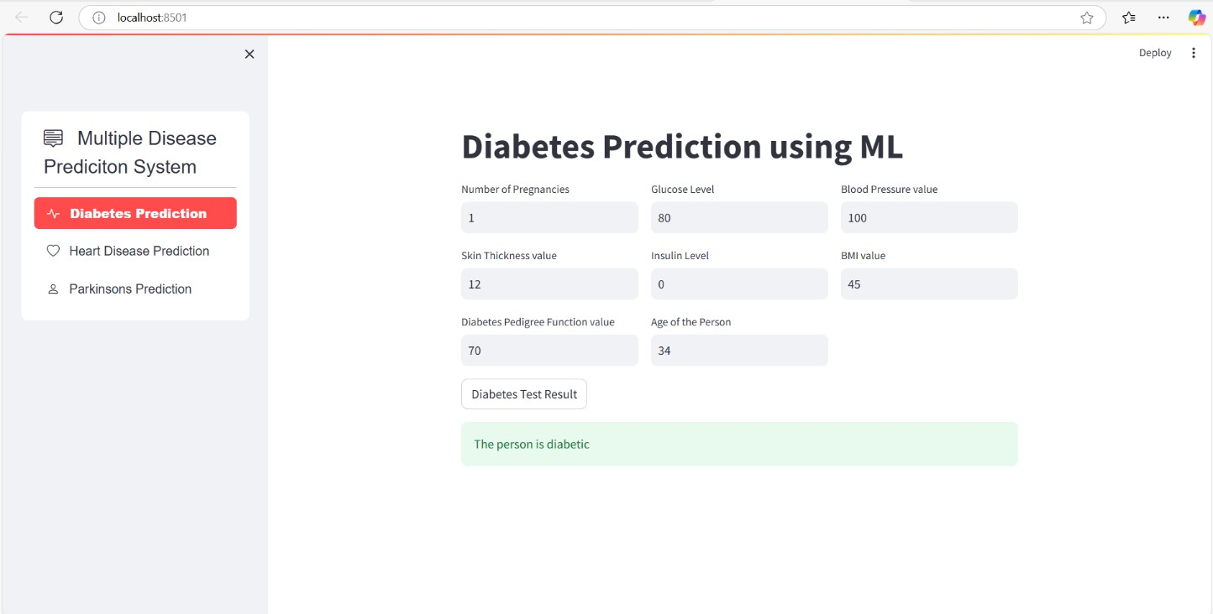

Figure 7.6: Displays the Diabetes Prediction Application
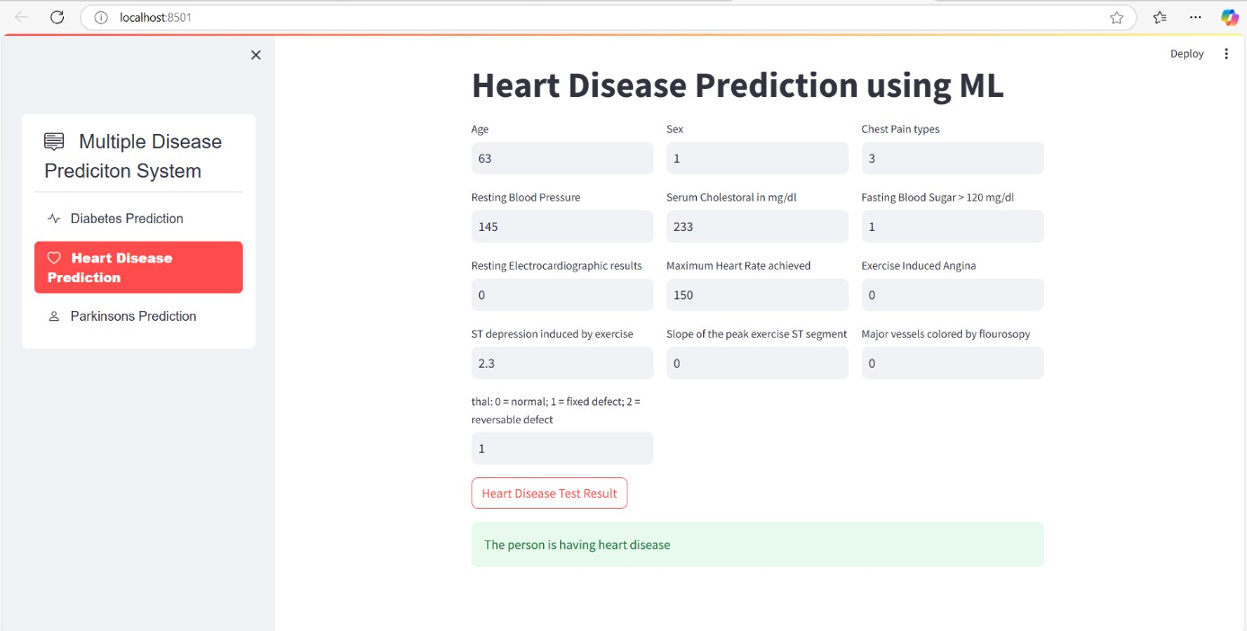

Figure 7.7: Displays the Heart Disease Prediction Application

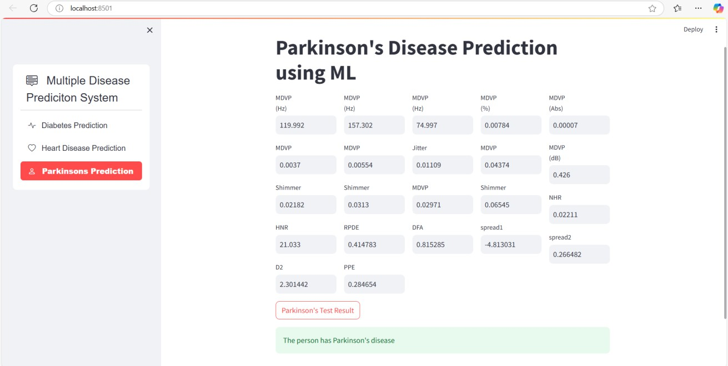
Figure 7.8: Displays the Parkinson’s Disease Prediction Application

They provide concise visual overviews of key insights. These typically include data trends, predictive accuracy, user demographics, and disease prevalence. Graphs, charts, and tables summarize application performance, such as accuracy rates, false positives, and model efficiency. Snapshots also highlight technological integrations like AI models, wearable device compatibility, and real-time monitoring capabilities. They may showcase case studies, illustrating successful predictions and early interventions. Additionally, they provide a clear understanding of scalability, user feedback, and potential future enhancements. Such snapshots are crucial for stakeholders to quickly grasp the application's impact and areas for improvement.
Algorithmic Performance: The project's approach of employing different methods for each health condition - Support Vector Machines (SVM) for Diabetes and Parkinson's, and Logistic Regression for Heart Disease - emphasizes the adaptability of the approach to diverse health issues. This strategic diversity showcases the project's versatility and its capacity to address specific challenges associated with different health conditions.
Confusion Matrices: Detailed performance charts, in the form of confusion matrices, offer valuable insights into the system's ability to avoid mistakes. These matrices contribute to the reliability of predictions, providing a granular understanding of the system's accuracy and aiding

in identifying areas for potential improvement.

Feature Importance: An exploration of feature importance identifies key health indicators for predictions, enhancing understanding of the factors influencing the models. This analysis contributes to the interpretability of the system, providing valuable insights into the underlying mechanisms of predictive modelling. Understanding feature importance is crucial for healthcare professionals and stakeholders to trust and interpret the predictions effectively.
Comparison with Existing Literature: The project's results align with existing studies on SVM and Logistic Regression, establishing the project's credibility within the broader context of healthcare research. The observed differences provide valuable insights into dataset nuances and algorithmic choices, contributing to the ongoing dialogue in healthcare literature. This alignment with existing literature strengthens the project's standing within the scientific community.
Limitations: Acknowledging project successes, the section emphasizes the importance of noting limitations. Despite the dataset's extensiveness, the recognition of potential gaps is crucial. This acknowledgment lays the groundwork for future improvements, with an understanding that research is an iterative process, and future iterations could benefit from larger and more diverse datasets.
Implications for Healthcare: The section underscores the substantial potential impact of the system on healthcare. The accuracy of predictions coupled with the user-friendly interface positions the project to empower healthcare professionals in early diagnosis. The emphasis on fostering a more responsive healthcare system aligns with broader goals of improving patient outcomes and overall healthcare efficacy.
Future Directions: The project's commitment to ongoing exploration is emphasized in this section. Ongoing efforts will explore new features and machine learning techniques, addressing limitations and advancing proactive healthcare technology. In essence, the system showcased effective predictive modelling, user-friendly interfaces, and holds promise for the future of proactive healthcare management. This comprehensive analysis highlights the project's achievements, challenges, and potential impact, setting the stage for continued advancements in the intersection of technology and healthcare.

CHAPTER 08

CONCLUSION AND FUTURE SCOPE
AI voice assistants will become more deeply integrated into daily life, offering greater personalization, seamless multi-device control, and more complex task management. The conclusion is that they are fundamentally changing human-computer interaction, making technology more intuitive and accessible.
- Market Growth and Adoption: The AI voice assistant market is experiencing robust expansion, with billions of devices in use globally and a strong Compound Annual Growth Rate (CAGR) projected over the next decade. This growth is fueled by the widespread adoption of smart devices (smartphones, speakers, in-car systems) and consumer demand for hands-free, intuitive interfaces.
- Enhanced User Experience: AI assistants significantly improve user productivity by automating routine tasks (setting reminders, managing calendars, information retrieval) and enabling multitasking. Users report high levels of satisfaction with the speed and ease of use, particularly in smart home and automotive settings.
- Technological Advancements: The shift from rule-based systems to those powered by advanced AI, Natural Language Processing (NLP), and Machine Learning (ML) has led to more natural, context-aware, and personalized interactions. The current integration of large language models (LLMs) promises to address previous limitations in understanding complex queries and maintaining conversational context.
- Industry Transformation: Voice AI is moving beyond consumer applications into enterprise sectors like customer service, healthcare, and logistics, offering benefits such as cost reduction, improved operational efficiency, and enhanced customer engagement.

FUTURE SCOPE: Despite its strengths, several areas need improvement.
Improved Speech Recognition
● Train a custom speech recognition model using machine learning for better offline
performance.
● Integrate Whisper AI or DeepSpeech for improved accuracy with non-native accents and noisy environments.
Enhanced Natural Language Processing (NLP)
● Use Transformer-based models like BERT or GPT-3.5 for context-aware intent recognition.
● Implement a self-learning mechanism where the assistant adapts to user preferences over time.
Better User Interface (UI/UX)
● Develop a fully interactive UI using Flask or React.js.
● Implement voice-controlled settings and feedback customization.
Expanded Functionality
● Add multi-language support to enhance accessibility.
● Integrate with smart home devices using IoT protocols.
● Develop an Android and iOS app to extend usability beyond desktops.
By implementing these improvements, our AI assistant can evolve into a more intelligent, adaptive, and widely usable system, making it a strong open-source alternative to commercial AI assistants. These references provided both theoretical insights and technical frameworks that supported the successful implementation of the AI-based voice assistant system.

BIBILOGRAPHY
- A. Vaswani, N. Shazeer, N. Parmar, J. Uszkoreit, L. Jones, A. N. Gomez, and I. Polosukhin, “Attention Is All You Need,” in Advances in Neural Information Processing Systems, vol. 30, 2017.
- G. Hinton, L. Deng, D. Yu, G. E. Dahl, A. Mohamed, N. Jaitly, and B. Kingsbury, “Deep Neural Networks for Acoustic Modeling in Speech Recognition,” IEEE Signal Processing Magazine, vol. 29, no. 6, pp. 82–97, 2012.
- A. Radford, K. Narasimhan, T. Salimans, and I. Sutskever, “Improving Language Understanding with Unsupervised Learning,” OpenAI, 2018.
- J. Chen, D. Parikh, and A. Gupta, “Learning from Language Explanations for Visual Reasoning,” in Proceedings of the European Conference on Computer Vision (ECCV), pp. 103–120, 2018.
- A. Baevski, H. Zhou, A. Mohamed, and M. Auli, “wav2vec 2.0: A Framework for Self-Supervised Learning of Speech Representations,” in Advances in Neural Information Processing Systems (NeurIPS), 2020.
- Google Developers, “Google Speech-to-Text API Documentation,” 2023. [Online]. Available: https://cloud.google.com/speech-to-text
- Mozilla DeepSpeech, “DeepSpeech Documentation,” 2023. [Online]. Available: https://deepspeech.readthedocs.io
- IBM Watson, “IBM Watson Speech Services Overview,” 2023. [Online]. Available: https://www.ibm.com/cloud/watson-speech-to-text

